Project Development Phase
Performance Test

Date | 01 September 2026
Team ID | Individual Project
Project Name | Software Installation Request Automation in ServiceNow Using Service Catalog and Workflows
Maximum Marks

Model Performance Testing:
S.No. | Parameter | Screenshot / Values
1. | Data Rendered | Service Catalog Requests, Requested Items, and Catalog Tasks. Verify the Request Number, catalog item variables, assigned Software Support team, task description, and task state.  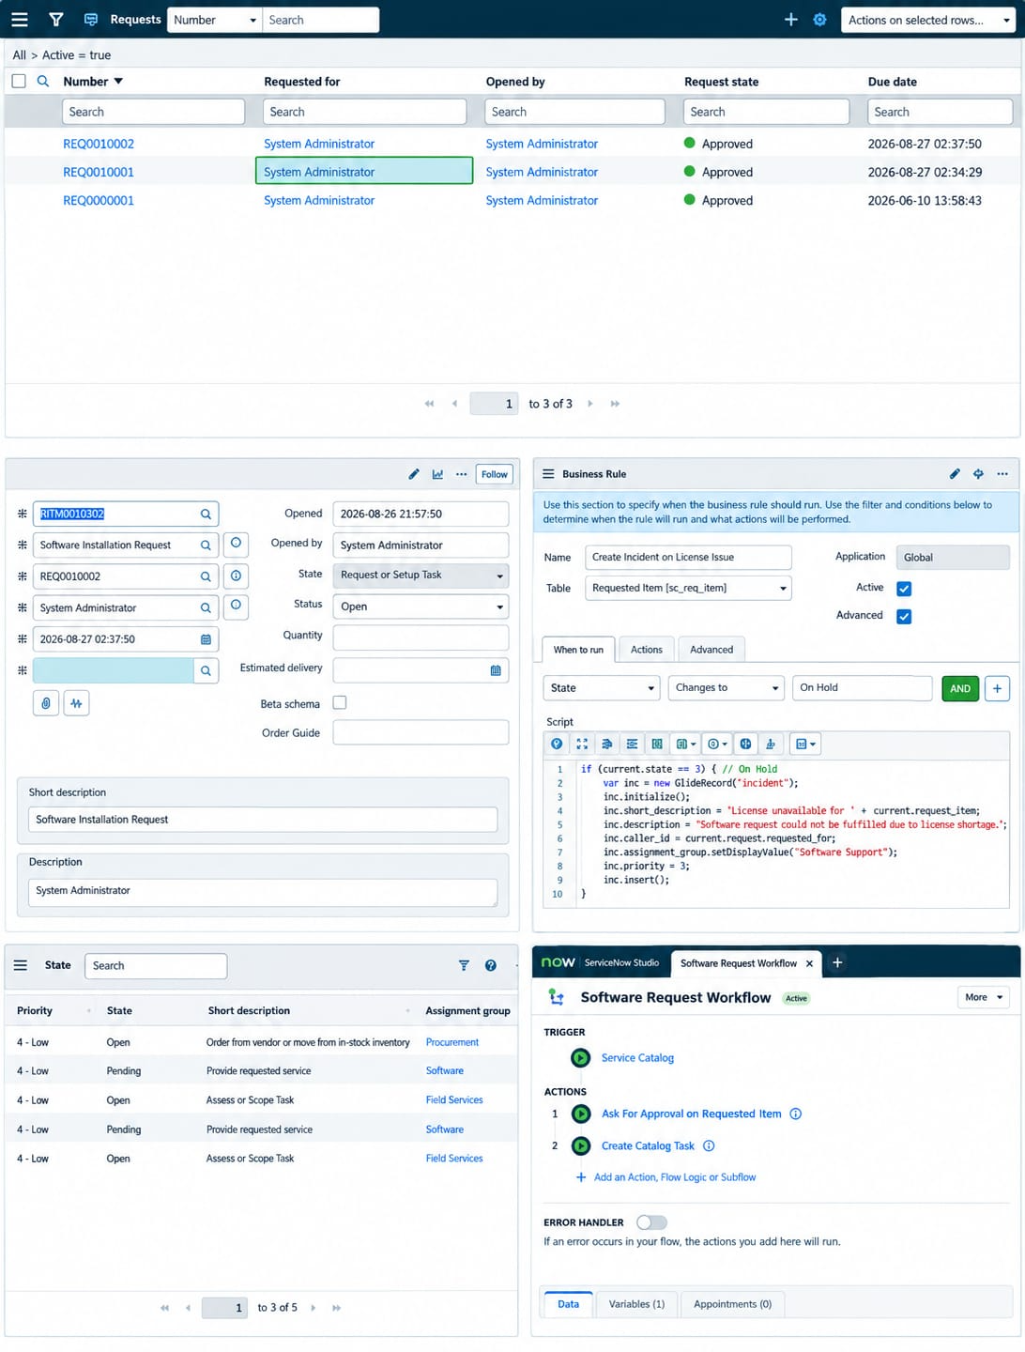
2. | Data Preprocessing | Service Catalog variables used for the request: Software Name, Version Required, License Justification, and Urgency. Configuration changes are captured in Update Sets.  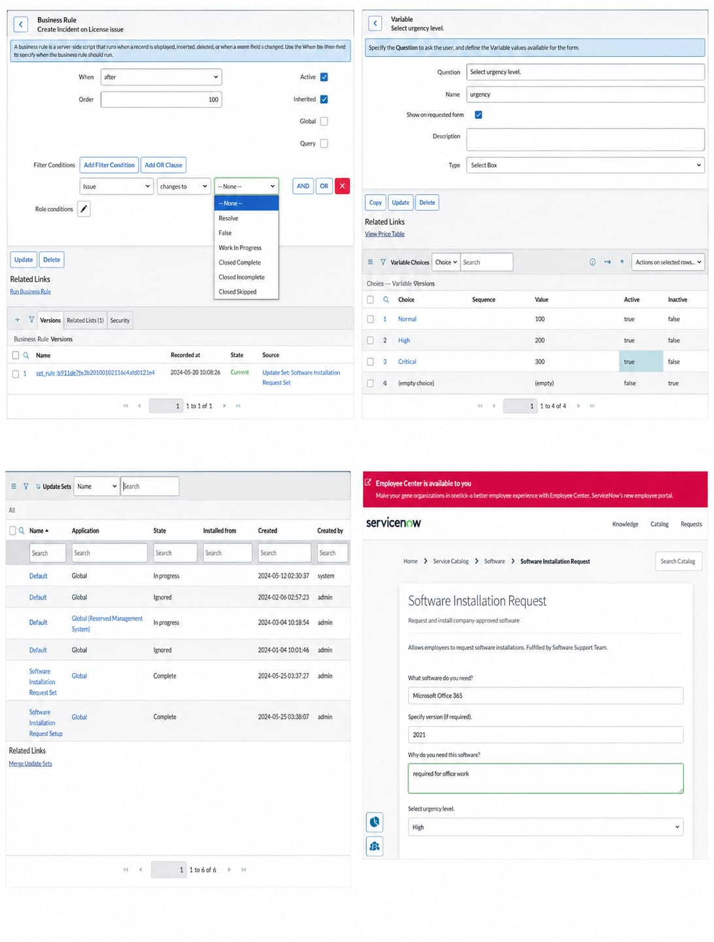
3. | Utilization of Filters | Not specified in the provided project document.
4. | Calculation fields Used | Not specified in the provided project document.
5. | Dashboard design | No of Visualizations / Graphs - Not specified in the provided project document.
6. | Story Design | No of Visualizations / Graphs - Not specified in the provided project document.

